DeJanae Faison

3/23/2025

Assignment 1.2 : GitHub Repository Setup

Link:

<https://github.com/D-Faison/CSD_340>

Local Directory:

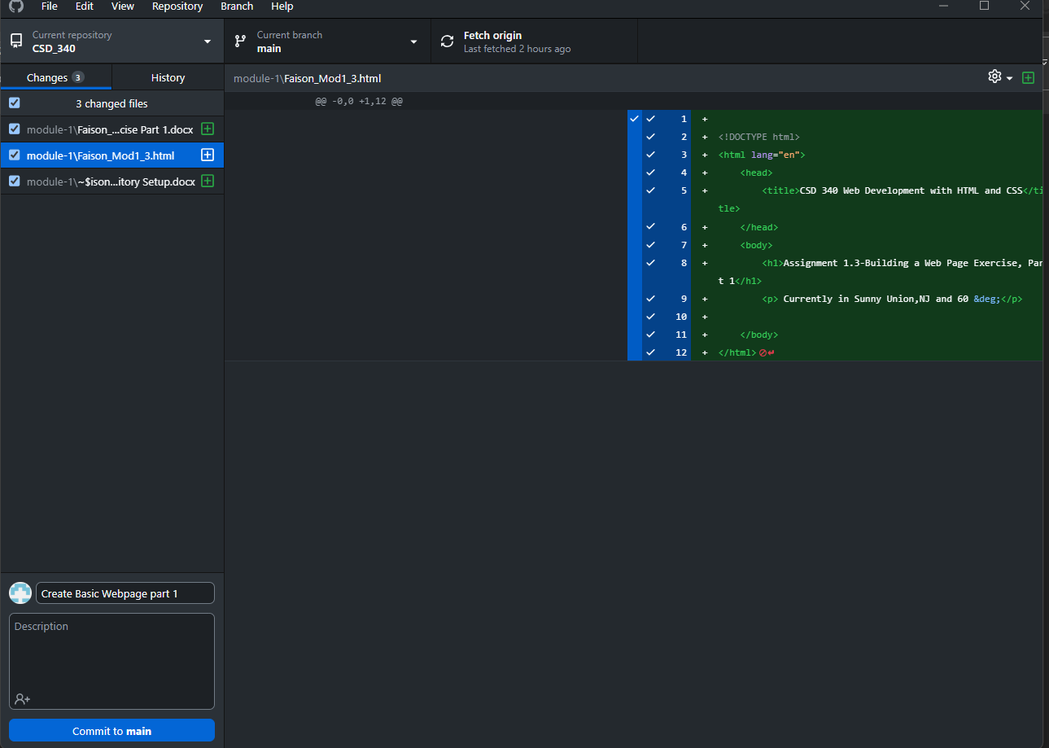

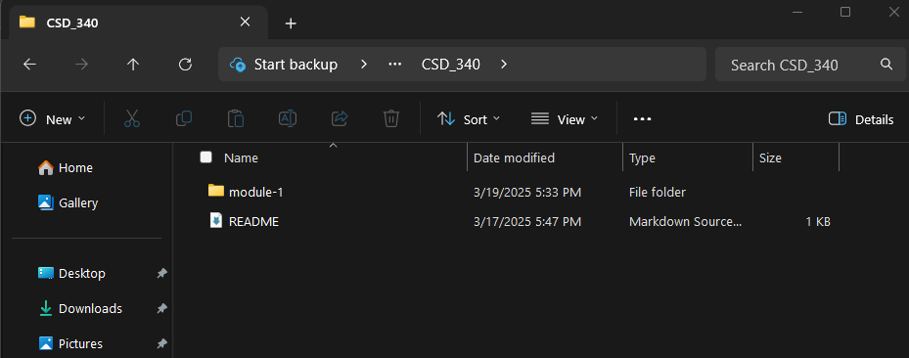

GitHub Repository:

